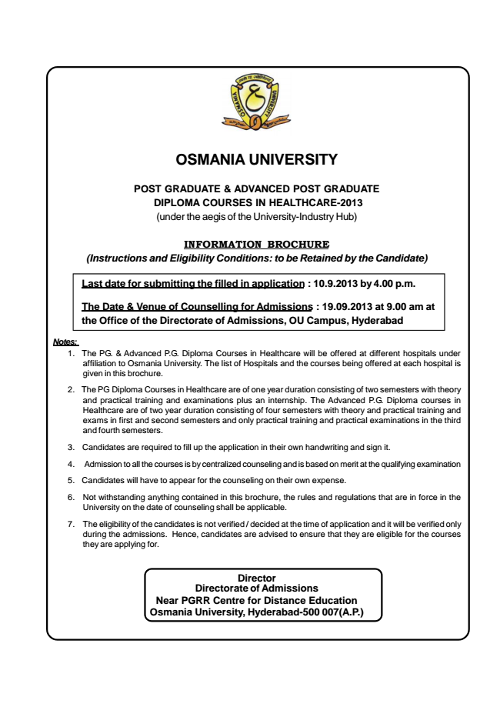

**OSMANIA UNIVERSITY**

**POST GRADUATE & ADVANCED POST GRADUATE DIPLOMA COURSES IN HEALTHCARE-2013 (under the aegis of the University-Industry Hub)**

***INFORMATION BROCHURE (Instructions and Eligibility Conditions: to be Retained by the Candidate)***

**Last date for submitting the filled in application : 10.9.2013 by 4.00 p.m.**

**The Date & Venue of Counselling for Admissions : 19.09.2013 at 9.00 am at the Office of the Directorate of Admissions, OU Campus, Hyderabad**

***Notes:***

1. The PG. & Advanced P.G. Diploma Courses in Healthcare will be offered at different hospitals under affiliation to Osmania University. The list of Hospitals and the courses being offered at each hospital is given in this brochure.

2. The PG Diploma Courses in Healthcare are of one year duration consisting of two semesters with theory and practical training and examinations plus an internship. The Advanced P.G. Diploma courses in Healthcare are of two year duration consisting of four semesters with theory and practical training and exams in first and second semesters and only practical training and practical examinations in the third and fourth semesters.

3. Candidates are required to fill up the application in their own handwriting and sign it.

4. Admission to all the courses is by centralized counseling and is based on merit at the qualifying examination

5. Candidates will have to appear for the counseling on their own expense.

6. Not withstanding anything contained in this brochure, the rules and regulations that are in force in the

University on the date of counseling shall be applicable.

7. The eligibility of the candidates is not verified / decided at the time of application and it will be verified only during the admissions. Hence, candidates are advised to ensure that they are eligible for the courses they are applying for.

**Director Directorate of Admissions Near PGRR Centre for Distance Education Osmania University, Hyderabad-500 007(A.P.)**

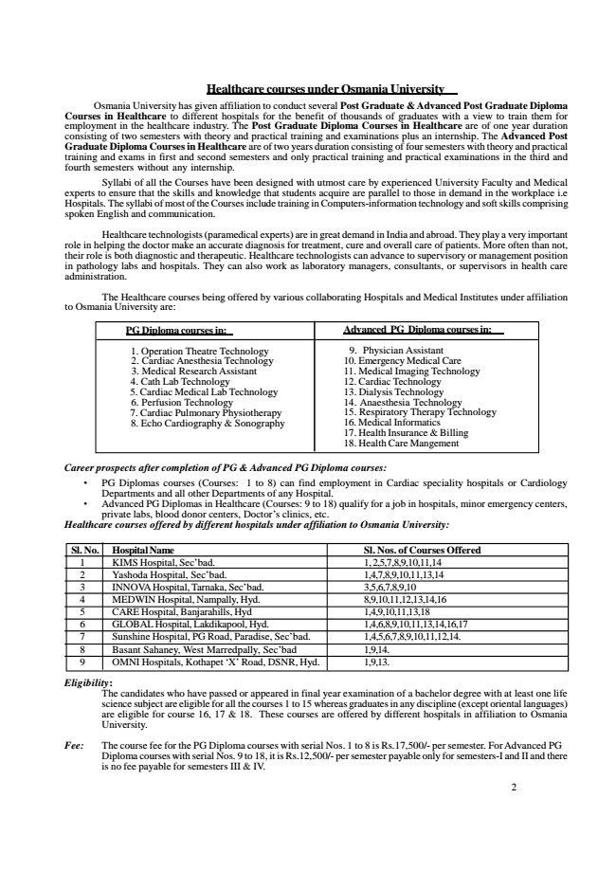

Healthcare courses under Osmania University Osmania University has given affiliation to conduct several Post Graduate & Advanced Post Graduate Diploma Courses in Healthcare to different hospitals for the benefit of thousands of graduates with a view to train them for employment consisting of in two the semesters healthcare with industry. theory The and practical Post Graduate training Diploma and examinations Courses in plus Healthcare an internship. are of The one Advanced year duration Post Graduate Diploma Courses in Healthcare are of two years duration consisting of four semesters with theory and practical training fourth semesters and exams without in first any and internship.

second semesters and only practical training and practical examinations in the third and

Syllabi of all the Courses have been designed with utmost care by experienced University Faculty and Medical experts Hospitals. to The ensure syllabi that of the most skills of the and Courses knowledge include that training students in acquire Computers-information are parallel to those technology in demand and soft in the skills workplace comprising i.e

spoken English and communication.

Healthcare technologists (paramedical experts) are in great demand in India and abroad. They play a very important role in helping the doctor make an accurate diagnosis for treatment, cure and overall care of patients. More often than not, their in pathology role is both labs diagnostic and hospitals. and therapeutic. They can also Healthcare work as technologists laboratory managers, can advance consultants, to supervisory or supervisors or management in health position care administration.

The Healthcare courses being offered by various collaborating Hospitals and Medical Institutes under affiliation to Osmania University are:

**PG Diploma courses in:**

**Advanced PG Diploma courses in:**

1. 2. Operation Cardiac Anesthesia Theatre Technology

Technology 3. Medical Research Assistant 5. 4. Cardiac Cath Lab Medical Technology

Lab Technology 6. Perfusion Technology 7. 8. Cardiac Echo Cardiography Pulmonary Physiotherapy

& Sonography

9. Physician Assistant 10. Emergency Medical Care 11. 12. Medical Cardiac Technology

Imaging Technology

13. Dialysis Technology 14. 15. Respiratory Anaesthesia Therapy Technology

Technology 16. Medical Informatics 17. 18. Health Health Insurance Care Mangement

& Billing

***Career prospects after completion of PG & Advanced PG Diploma courses:***

• PG Departments Diplomas and courses all other (Courses: Departments 1 to of 8) any can Hospital.

find employment in Cardiac speciality hospitals or Cardiology

• Advanced PG Diplomas in Healthcare (Courses: 9 to 18) qualify for a job in hospitals, minor emergency centers, Healthcare private courses labs, offered blood donor by different centers, hospitals Doctor’s under clinics, affiliation etc.

***to Osmania University:***

**Sl. No. Hospital Name Sl. Nos. of Courses Offered**

1 KIMS Hospital, Sec’bad. 1, 2,5,7,8,9,10,11,14 2 Yashoda Hospital, Sec’bad. 1,4,7,8,9,10,11,13,14 3 INNOVA Hospital, Tarnaka, Sec’bad. 3,5,6,7,8,9,10 4 MEDWIN Hospital, Nampally, Hyd. 8,9,10,11,12,13,14,16 5 CARE Hospital, Banjarahills, Hyd 1,4,9,10,11,13,18 6 GLOBAL Hospital, Lakdikapool, Hyd. 1,4,6,8,9,10,11,13,14,16,17 7 Sunshine Hospital, PG Road, Paradise, Sec’bad. 1,4,5,6,7,8,9,10,11,12,14. 8 Basant Sahaney, West Marredpally, Sec’bad 1,9,14. 9 OMNI Hospitals, Kothapet ‘X’ Road, DSNR, Hyd. 1,9,13.

***Eligibility:***

The science candidates subject are who eligible have passed for all the or appeared courses 1 in to final 15 whereas year examination graduates in of any a bachelor discipline degree (except with oriental at least languages) one life

are eligible for course 16, 17 & 18. These courses are offered by different hospitals in affiliation to Osmania University.

Fee: The course fee for the PG Diploma courses with serial Nos. 1 to 8 is Rs.17,500/- per semester. For Advanced PG

Diploma is no fee payable courses with for semesters serial Nos. III 9 & to IV.

18, it is Rs.12,500/- per semester payable only for semesters-I and II and there

2

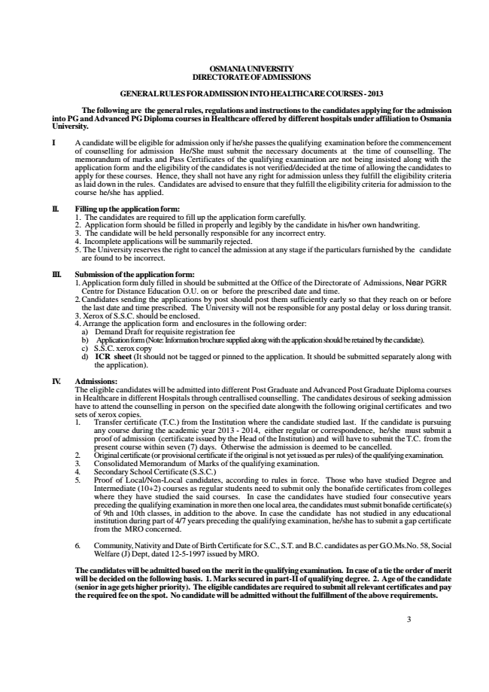

**OSMANIA UNIVERSITY DIRECTORATE OFADMISSIONS**

**GENERAL RULES FORADMISSION INTO HEALTHCARE COURSES - 2013**

**The following are the general rules, regulations and instructions to the candidates applying for the admission into PG and Advanced PG Diploma courses in Healthcare offered by different hospitals under affiliation to Osmania University.**

I A candidate will be eligible for admission only if he/she passes the qualifying examination before the commencement of counselling for admission He/She must submit the necessary documents at the time of counselling. The memorandum of marks and Pass Certificates of the qualifying examination are not being insisted along with the application form and the eligibility of the candidates is not verified/decided at the time of allowing the candidates to apply for these courses. Hence, they shall not have any right for admission unless they fulfill the eligibility criteria as laid down in the rules. Candidates are advised to ensure that they fulfill the eligibility criteria for admission to the course he/she has applied.

**II. Filling up the application form:**

1. The candidates are required to fill up the application form carefully. 2. Application form should be filled in properly and legibly by the candidate in his/her own handwriting. 3. The candidate will be held personally responsible for any incorrect entry. 4. Incomplete applications will be summarily rejected. 5. The University reserves the right to cancel the admission at any stage if the particulars furnished by the candidate

are found to be incorrect.

**III. Submission of the application form:**

1. Application form duly filled in should be submitted at the Office of the Directorate of Admissions, Near PGRR

Centre for Distance Education O.U. on or before the prescribed date and time. 2.Candidates sending the applications by post should post them sufficiently early so that they reach on or before the last date and time prescribed. The University will not be responsible for any postal delay or loss during transit. 3. Xerox of S.S.C. should be enclosed. 4. Arrange the application form and enclosures in the following order:

a) Demand Draft for requisite registration fee b) Application form (Note: Information brochure supplied along with the application should be retained by the candidate). c) S.S.C. xerox copy d) ICR sheet (It should not be tagged or pinned to the application. It should be submitted separately along with

the application).

**IV. Admissions:**

The eligible candidates will be admitted into different Post Graduate and Advanced Post Graduate Diploma courses in Healthcare in different Hospitals through centrallised counselling. The candidates desirous of seeking admission have to attend the counselling in person on the specified date alongwith the following original certificates and two sets of xerox copies. 1. Transfer certificate (T.C.) from the Institution where the candidate studied last. If the candidate is pursuing any course during the academic year 2013 - 2014, either regular or correspondence, he/she must submit a proof of admission (certificate issued by the Head of the Institution) and will have to submit the T.C. from the present course within seven (7) days. Otherwise the admission is deemed to be cancelled. 2. Original certificate (or provisional certificate if the original is not yet issued as per rules) of the qualifying examination. 3. Consolidated Memorandum of Marks of the qualifying examination. 4. Secondary School Certificate (S.S.C.) 5. Proof of Local/Non-Local candidates, according to rules in force. Those who have studied Degree and Intermediate (10+2) courses as regular students need to submit only the bonafide certificates from colleges where they have studied the said courses. In case the candidates have studied four consecutive years preceding the qualifying examination in more then one local area, the candidates must submit bonafide certificate(s) of 9th and 10th classes, in addition to the above. In case the candidate has not studied in any educational institution during part of 4/7 years preceding the qualifying examination, he/she has to submit a gap certificate from the MRO concerned.

6. Community, Nativity and Date of Birth Certificate for S.C., S.T. and B.C. candidates as per G.O.Ms.No. 58, Social

Welfare (J) Dept, dated 12-5-1997 issued by MRO.

**The candidates will be admitted based on the merit in the qualifying examination. In case of a tie the order of merit will be decided on the following basis. 1. Marks secured in part-II of qualifying degree. 2. Age of the candidate (senior in age gets higher priority). The eligible candidates are required to submit all relevant certificates and pay the required fee on the spot. No candidate will be admitted without the fulfillment of the above requirements.**

3

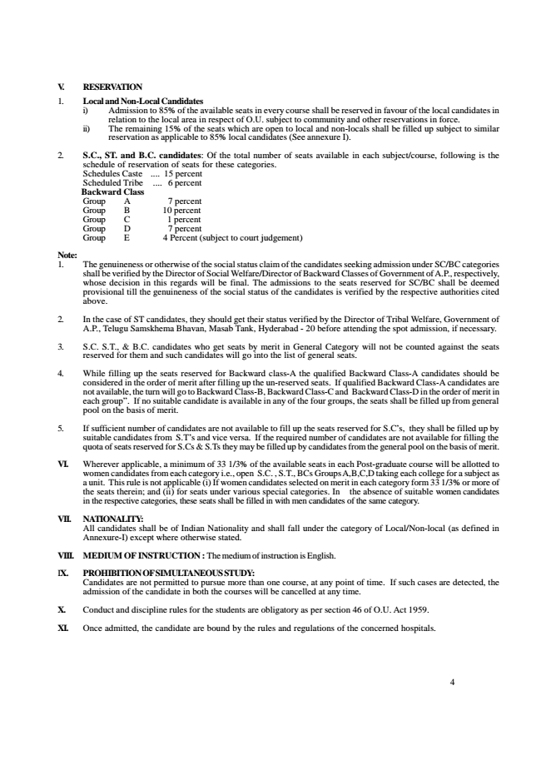

**V. RESERVATION 1. Local and Non-Local Candidates**

i) Admission to 85% of the available seats in every course shall be reserved in favour of the local candidates in

relation to the local area in respect of O.U. subject to community and other reservations in force. ii) The remaining 15% of the seats which are open to local and non-locals shall be filled up subject to similar

reservation as applicable to 85% local candidates (See annexure I).

2. S.C., ST. and B.C. candidates: Of the total number of seats available in each subject/course, following is the

schedule of reservation of seats for these categories. Schedules Caste .... 15 percent Scheduled Tribe .... 6 percent Backward Class Group A 7 percent Group B 10 percent Group C 1 percent Group D 7 percent Group E 4 Percent (subject to court judgement)

Note: 1. The genuineness or otherwise of the social status claim of the candidates seeking admission under SC/BC categories shall be verified by the Director of Social Welfare/Director of Backward Classes of Government of A.P., respectively, whose decision in this regards will be final. The admissions to the seats reserved for SC/BC shall be deemed provisional till the genuineness of the social status of the candidates is verified by the respective authorities cited above.

2. In the case of ST candidates, they should get their status verified by the Director of Tribal Welfare, Government of

A.P., Telugu Samskhema Bhavan, Masab Tank, Hyderabad - 20 before attending the spot admission, if necessary.

3. S.C. S.T., & B.C. candidates who get seats by merit in General Category will not be counted against the seats

reserved for them and such candidates will go into the list of general seats.

4. While filling up the seats reserved for Backward class-A the qualified Backward Class-A candidates should be considered in the order of merit after filling up the un-reserved seats. If qualified Backward Class-A candidates are not available, the turn will go to Backward Class-B, Backward Class-C and Backward Class-D in the order of merit in each group”. If no suitable candidate is available in any of the four groups, the seats shall be filled up from general pool on the basis of merit.

5. If sufficient number of candidates are not available to fill up the seats reserved for S.C’s, they shall be filled up by suitable candidates from S.T’s and vice versa. If the required number of candidates are not available for filling the quota of seats reserved for S.Cs & S.Ts they may be filled up by candidates from the general pool on the basis of merit.

VI. Wherever applicable, a minimum of 33 1/3% of the available seats in each Post-graduate course will be allotted to women candidates from each category i.e., open S.C. , S.T., BCs Groups A,B,C,D taking each college for a subject as a unit. This rule is not applicable (i) If women candidates selected on merit in each category form 33 1/3% or more of the seats therein; and (ii) for seats under various special categories. In the absence of suitable women candidates in the respective categories, these seats shall be filled in with men candidates of the same category.

**VII. NATIONALITY:**

All candidates shall be of Indian Nationality and shall fall under the category of Local/Non-local (as defined in Annexure-I) except where otherwise stated.

VIII. MEDIUM OF INSTRUCTION :The medium of instruction is English.

**IX. PROHIBITION OF SIMULTANEOUS STUDY:**

Candidates are not permitted to pursue more than one course, at any point of time. If such cases are detected, the admission of the candidate in both the courses will be cancelled at any time.

X. Conduct and discipline rules for the students are obligatory as per section 46 of O.U. Act 1959.

XI. Once admitted, the candidate are bound by the rules and regulations of the concerned hospitals.

4

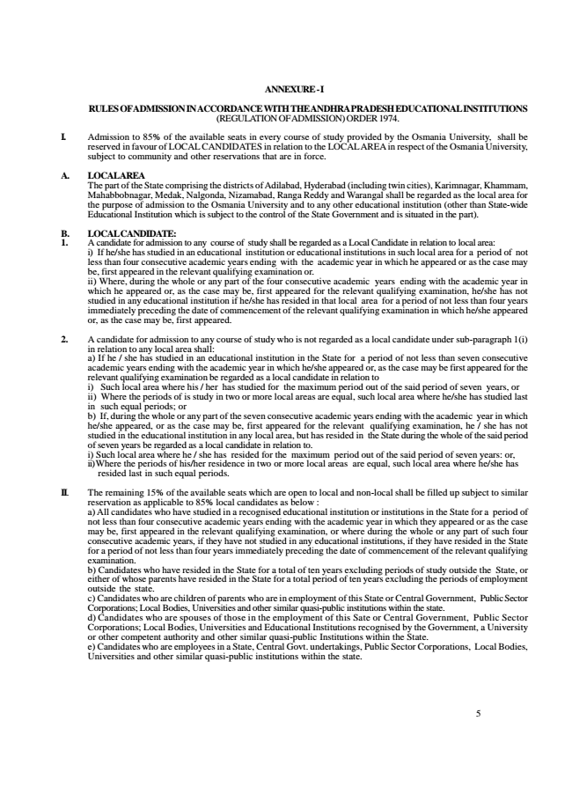

**ANNEXURE - I**

**RULES OF ADMISSION IN ACCORDANCE WITH THE ANDHRA PRADESH EDUCATIONAL INSTITUTIONS (REGULATION OF ADMISSION) ORDER 1974.**

I. Admission to 85% of the available seats in every course of study provided by the Osmania University, shall be reserved in favour of LOCAL CANDIDATES in relation to the LOCAL AREA in respect of the Osmania University, subject to community and other reservations that are in force.

**A. LOCAL AREA**

The part of the State comprising the districts of Adilabad, Hyderabad (including twin cities), Karimnagar, Khammam, Mahabbobnagar, Medak, Nalgonda, Nizamabad, Ranga Reddy and Warangal shall be regarded as the local area for the purpose of admission to the Osmania University and to any other educational institution (other than State-wide Educational Institution which is subject to the control of the State Government and is situated in the part).

B. LOCAL CANDIDATE: 1. A candidate for admission to any course of study shall be regarded as a Local Candidate in relation to local area:

i) If he/she has studied in an educational institution or educational institutions in such local area for a period of not less than four consecutive academic years ending with the academic year in which he appeared or as the case may be, first appeared in the relevant qualifying examination or. ii) Where, during the whole or any part of the four consecutive academic years ending with the academic year in which he appeared or, as the case may be, first appeared for the relevant qualifying examination, he/she has not studied in any educational institution if he/she has resided in that local area for a period of not less than four years immediately preceding the date of commencement of the relevant qualifying examination in which he/she appeared or, as the case may be, first appeared.

2. A candidate for admission to any course of study who is not regarded as a local candidate under sub-paragraph 1(i)

in relation to any local area shall: a) If he / she has studied in an educational institution in the State for a period of not less than seven consecutive academic years ending with the academic year in which he/she appeared or, as the case may be first appeared for the relevant qualifying examination be regarded as a local candidate in relation to i) Such local area where his / her has studied for the maximum period out of the said period of seven years, or ii) Where the periods of is study in two or more local areas are equal, such local area where he/she has studied last in such equal periods; or b) If, during the whole or any part of the seven consecutive academic years ending with the academic year in which he/she appeared, or as the case may be, first appeared for the relevant qualifying examination, he / she has not studied in the educational institution in any local area, but has resided in the State during the whole of the said period of seven years be regarded as a local candidate in relation to. i) Such local area where he / she has resided for the maximum period out of the said period of seven years: or, ii)Where the periods of his/her residence in two or more local areas are equal, such local area where he/she has

resided last in such equal periods.

II. The remaining 15% of the available seats which are open to local and non-local shall be filled up subject to similar

reservation as applicable to 85% local candidates as below : a) All candidates who have studied in a recognised educational institution or institutions in the State for a period of not less than four consecutive academic years ending with the academic year in which they appeared or as the case may be, first appeared in the relevant qualifying examination, or where during the whole or any part of such four consecutive academic years, if they have not studied in any educational institutions, if they have resided in the State for a period of not less than four years immediately preceding the date of commencement of the relevant qualifying examination. b) Candidates who have resided in the State for a total of ten years excluding periods of study outside the State, or either of whose parents have resided in the State for a total period of ten years excluding the periods of employment outside the state. c) Candidates who are children of parents who are in employment of this State or Central Government, Public Sector Corporations; Local Bodies, Universities and other similar quasi-public institutions within the state. d) Candidates who are spouses of those in the employment of this Sate or Central Government, Public Sector Corporations; Local Bodies, Universities and Educational Institutions recognised by the Government, a University or other competent authority and other similar quasi-public Institutions within the State. e) Candidates who are employees in a State, Central Govt. undertakings, Public Sector Corporations, Local Bodies, Universities and other similar quasi-public institutions within the state.

5